EXPERIMENT 4

RELATIONAL MODEL FOR SAILOR BOAT DATABASE

**Aim**: Draw a relational model for sailor database.

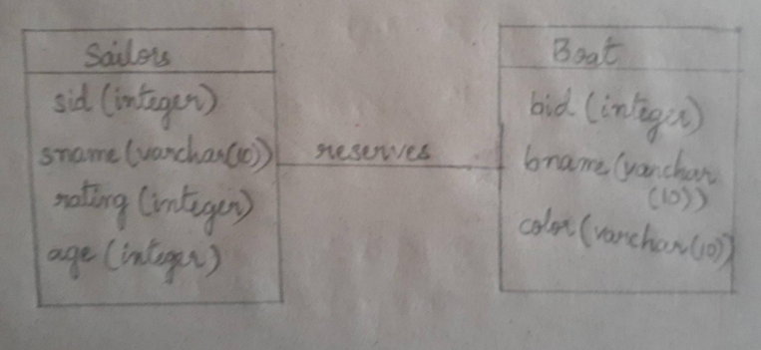

Relational model:

